**WORKING WITH OPERATORS:**

PROBLEM STATEMENT:

* David needs to write a program to calculate the net payable salary.The program will take basic salary as an input from the user and calculate the total salary along with the following components:
* HRA, which 50%of the basic salary
* Special allowance,which is 75% of the basic salary
* PF deduction,which is 12% of the basic salary

After calculating the preceding salary componenets, the net payable salary should be display.Help David to perform the Preceding requirement.

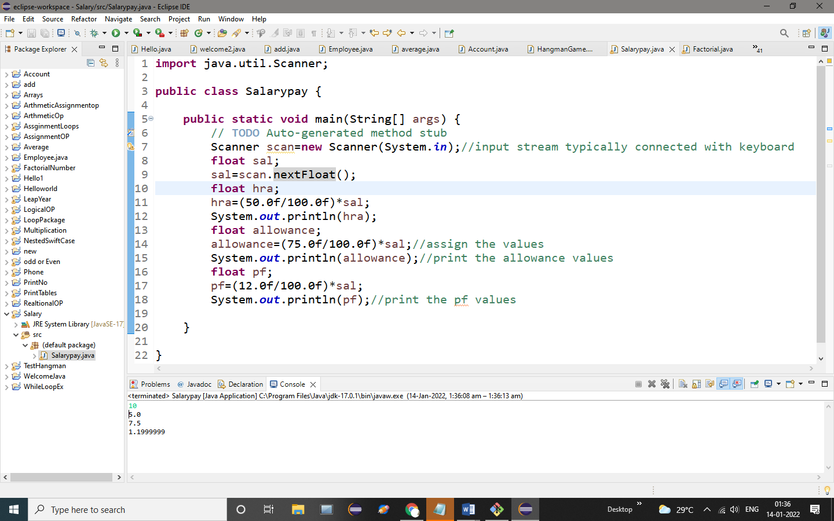

OUTPUT:

10

5.0

7.5

1.1999999